TEAM 1-K15T1-VANLANGUNI
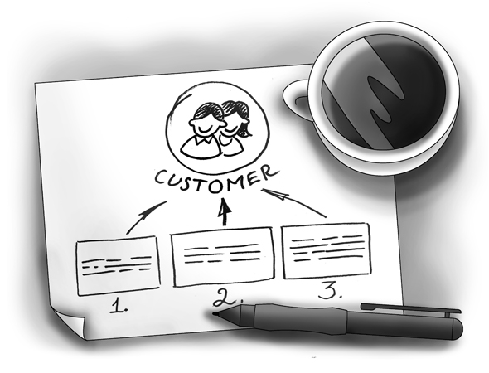
SOFTWARE REQUIREMENT SPECIFICATION
Meeting Room Booking System (MRBS)
Ver1.6
Prepared by: Team 1-K15T1-Vanlanguni
12/6/12

Team Members:
- Le Dinh Thach Huyen (Member)
- Dang Huy Son (Technical Researcher)
- Do Minh Tam (Technical Researcher & Recorder)
- Nguyen Trung Tin (Member)
- Dang Nguyen Toan (Member)
- Le Thi Bich Van (Project Manager)
Abstract:
Meeting Room Booking System is program manages the room meeting, statistic and report for IT faculty department of Van Lang University. This document describes the requirements for the Room Meeting Booking System product
Revision History
Content | Date | Author | Version
Define template and main contents | 6/12/12 | Van Le | Ver0.1
Update template and main contents | 6/16/12 | Tam Do | Ver1.0
Update content draft | 6/17/12 | Tam Do | Ver1.1
Update content UC diagram and UC description of Tam Do into SRS | 6/20/12  7/1/12 | Huyen Le | Ver1.2  Ver 1.3
Update “Acceptance Criteria” | 7/2/12 | Van Le | Ver1.4
Update  “3. The Proposed Logical System”  “5.3.1. Performance Requirements”  “5.3.2. Usability Requirement” | 7/3/12 | Huyen Le | Ver 1.5
Update “3.3. Product Functions” | 7/10/12 | Van Le | Ver 1.6

Table of contents
1. Introduction 5
1.1. Purpose 5
1.2. Scope of project 5
1.3. Information of stakeholder for MRBS project 5
1.3.1. The customer for MRBS project 5
1.3.2. The Suppervisor for MRBS project 5
1.3.3. Our team for the project is called Team 1-K15T1-Vanlanguni and consists of 6
1.4. Definition and Acronyms 6
1.5. References 6
2. The Existing Logical System 6
3. The Proposed Logical System 7
4. System Overview 7
4.1. Product Perspective 7
4.2. User Analysis and Characteristics 7
4.3. Product Functions 8
4.4. Operating Environment 8
5. Specific Requirement 9
5.1. External Interface Requirement 9
5.1.1. User Interfaces 9
5.2. System Features 9
5.2.1. Actor Table 9
5.2.2. Usecase Diagram 10
5.3. Software Quality Attribute 19
5.3.1. Performance Requirements 20
5.3.2. Usability Requirements 20
5.3.3. Other Requirements 20
5.4. Constraint Table 20
6. Business rule 20
7. Acceptance Criteria 20
8. Appendix 1 20

List of figure
Figure4. 3. 1 - Requirement Breakdown Structure 8

Figure 5.1.1.1. 1 - User Interfaces Architecture 9

Figure 5.2.1. 1 - Usecase Diagram Level 1 10

List of table
Table 1. 4. 1 - Definition and Acronyms 6
Table 3 .2 . 1 - Actor in MRBS 7
Table 4. 2. 3. 1 - Use-case Description Level 1 18

Introduction
This document formally states the requirements for the RMBS product.

Purpose
The SRS document created by the team 11 provides both the functional and non-functional requirements of the Meeting Room Booking System (MRBS). This document includes definitions, specifications, and other information that will be helpful for the customer and for the team 11 to have a clear understanding of the system to be developed.
From this document, the customer will be able to understand our team’s comprehension of the requirements. This document can be updated or revised when required by the customer as we consider our customer’s demands important for our project. This document will evolve according to the requirement.

Scope of project
These requirements have been priority into three levels:
  - Essential
The minimum set of requirements for the product to be accepted.
  - Highly Desirable
Requirements that are considered to be likely inclusions to the product, time permitting.
  - Desirable
Requirements that are not likely to be added in this version, but should be considered for future modifications.
MRBS will help the faculty officer manages the meeting room, statistic and report for IT faculty department, use for one branch, one computer and use bar code

Information of stakeholder for MRBS project

The customer for MRBS project
Mr. Nam Vu, Teacher of Van Lang University
Phone: 0903308809
E–Mail: mailto:vuthenam@vanlanguni.edu.vn

The Suppervisor for MRBS project

Mr. Nam Vu, Teacher of Van Lang University
Phone: 090.330.8809
E–Mail: mailto:vuthenam@vanlanguni.edu.vn
Mr. Phung Bui, Teacher of Van Lang University
Phone: 090.999.7556
E–Mail: mailto:buiminhphung@vanlanguni.edu.vn

Mr. Thanh Vo, Mentor for Project Team
Phone: 090.240.5778
E–Mail: mailto:vnthanh25@gmail.com

Our team for the project is called Team 1-K15T1-Vanlanguni and consists of

Le Dinh Thach Huyen, Member
Phone: 090.918.8571
E–Mail: mailto:radinkasim@gmail.com

Dang Huy Son, Technical Researcher
Phone: 0199.8766.424
E–Mail: mailto:slavril.2009@gmail.com

Do Minh Tam, Technical Researcher & Recorder
Phone: 0126.7322.839
E–Mail: mailto:tamdo4@gmail.com
Nguyen Trung Tin, Member
Phone: 0128.4317.131
E–Mail: mailto:trungtin119@gmail.com

Dang Nguyen Toan, Member
Phone: 093.768.2000
E–Mail: mailto:dangtrannguyentoan@gmail.com
Le Thi Bich Van, Project Manager
Phone: 0985.197.070
E–Mail: vanbichthile@gmail.com, vanle12@vanlanguni.vn

Definition and Acronyms
No. | Term | Definition
1. | MRBS | Meeting Room Booking System
2. | SRS | Software Requirement Specification
3. | GUI | Graphical User Interface
4. | CMU | Carnegie Mellon University
5. | FC | Function
6. | FT | Feature
7. | HPIMS | HMC POI Inspection & Management System
Table 1. 4. 1 - Definition and Acronyms

References
HPIMS_SRS_v1.03.doc of CMU

The Existing Logical System
The client has no existing system for RMBS

System Overview

Product Perspective
MRBS is aimed toward a person who has considerable number of registry meeting room in IT department, and so needs software assistance for book meeting room and computations regarding the priority. MRBS should be user friendly, quick to learn and reliable software for above purpose

User Analysis and Characteristics
The two primary actors in MRBS are user (Booking Room Manager) and Administrator
No. | Actor | Description
1. | Administrator | Administrator shall set the right to use MRBS system: Account management and Recycle bin management
2. | Booking Room Manager | Faculty Officer shall manage account, borrower, room borrow, static and report, room,, setting system. And the booking room manager shall send out notifications through an automated email to borrower
Table 3 .2 . 1 - Actor in MRBS

Product Functions
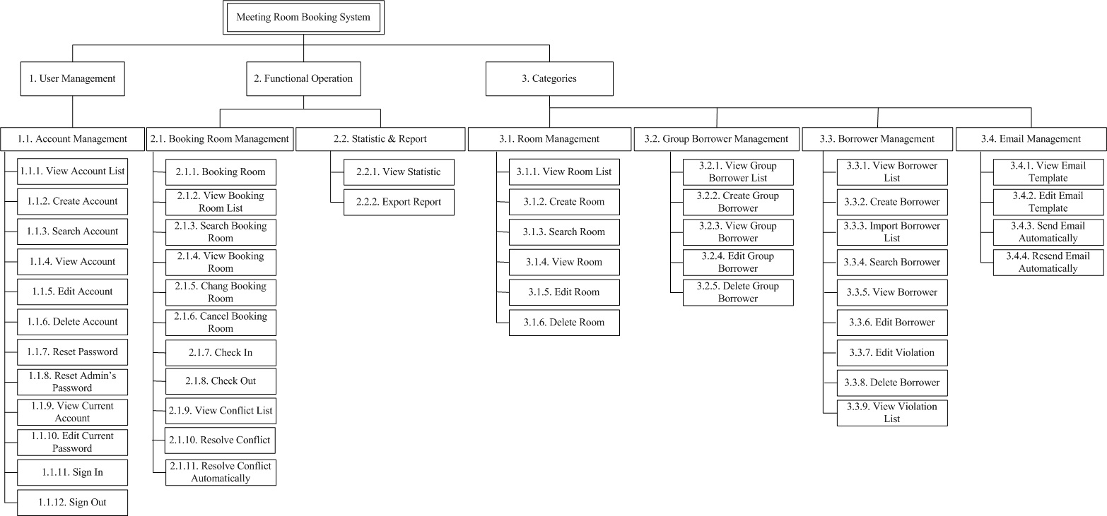
Figure4. 3. 1 - Requirement Breakdown Structure

Operating Environment
The target system is a standalone application in a PC environment on Microsoft Windows XP, 7 with Microsoft SQL Server 2008.
The system will be developed using platform-independent C# language.

Specific Requirement

External Interface Requirement

User Interfaces
This user interface is prototype made after discussion among team 11. This will help the client to see the user interface of our final program artifact in this project. The contents and appearance can be changed or refined based on the user’s requirement and technical constraints.

User Interfaces Architecture
This is the overall architecture of MRBS prototypical user interface. The user interface is divided into three, mainly based on the functions of MRBS.
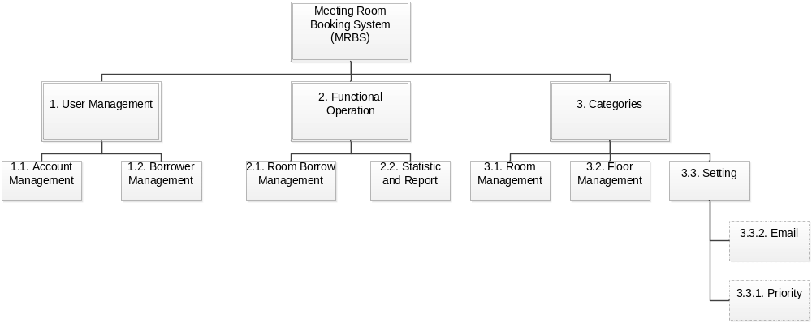
Figure 5.1.1.1. 1 - User Interfaces Architecture

System Features

Actor Table
Name | Responsibility | Role
Administrator | Administrator is a | Administrator
Booking Borrower | Booking Borrower is a | Officer Administrator

Usecase Diagram
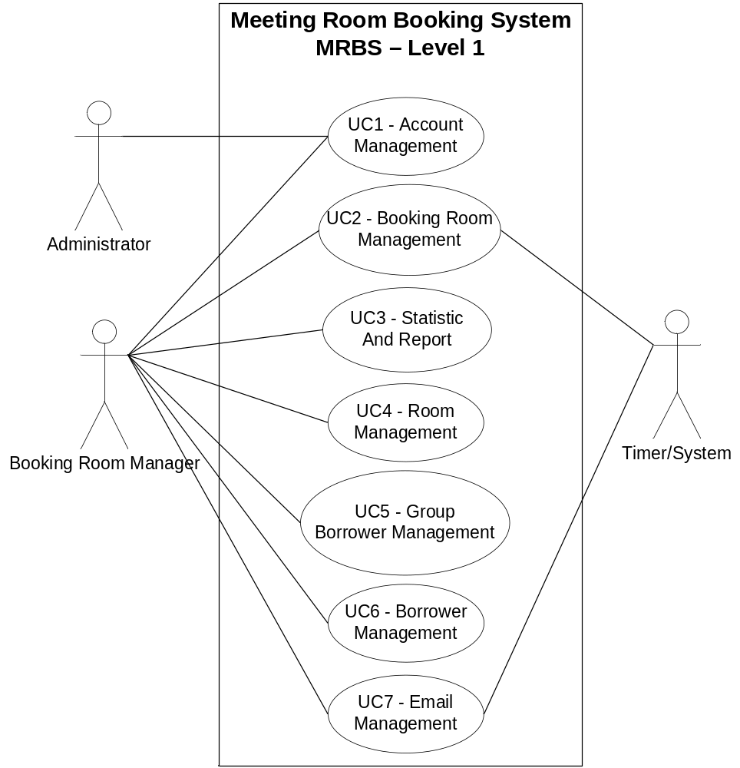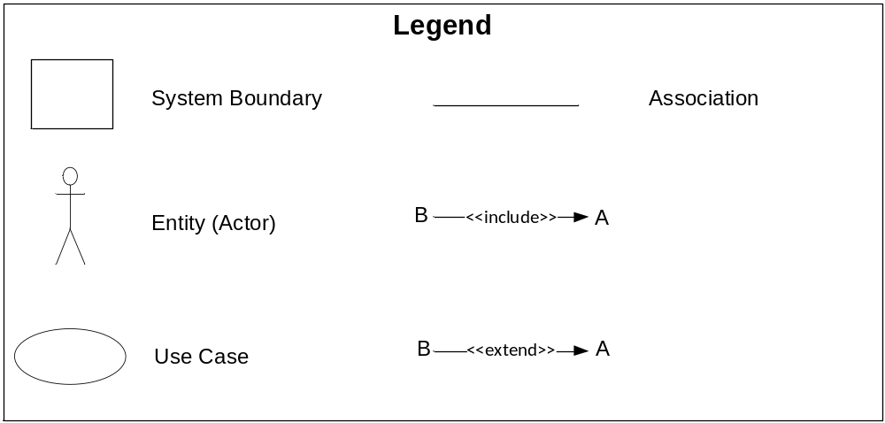 Figure 5.2.1. 1 - Usecase Diagram Level 1
      - Account Management
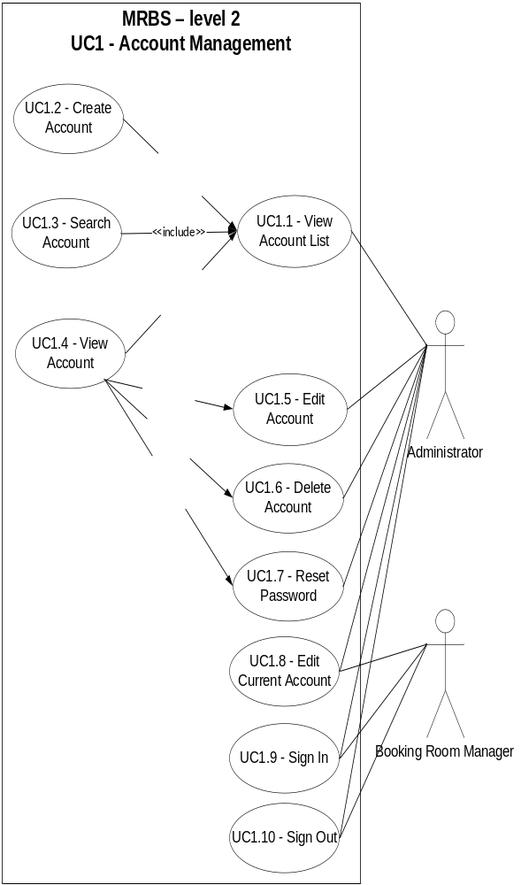
      - Booking Room Management
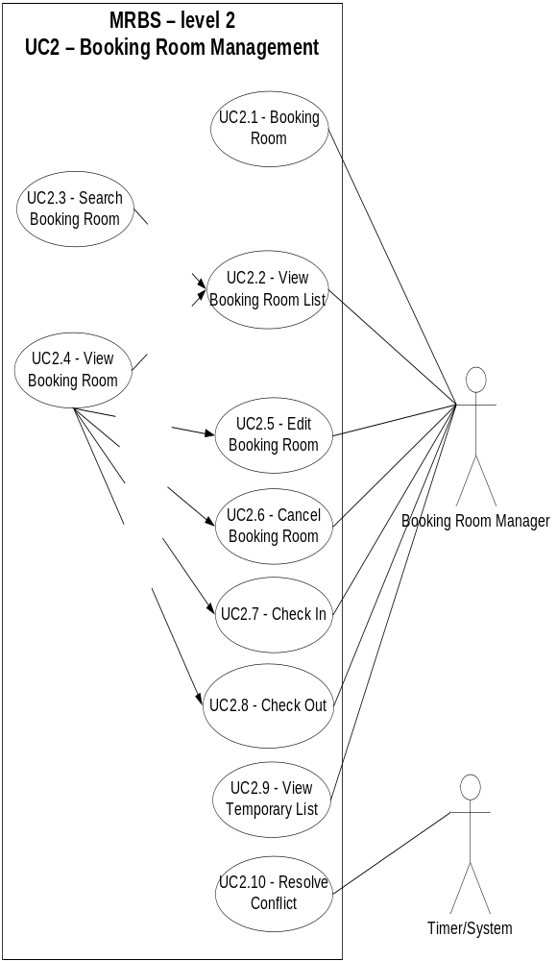
      - Statistic And Report
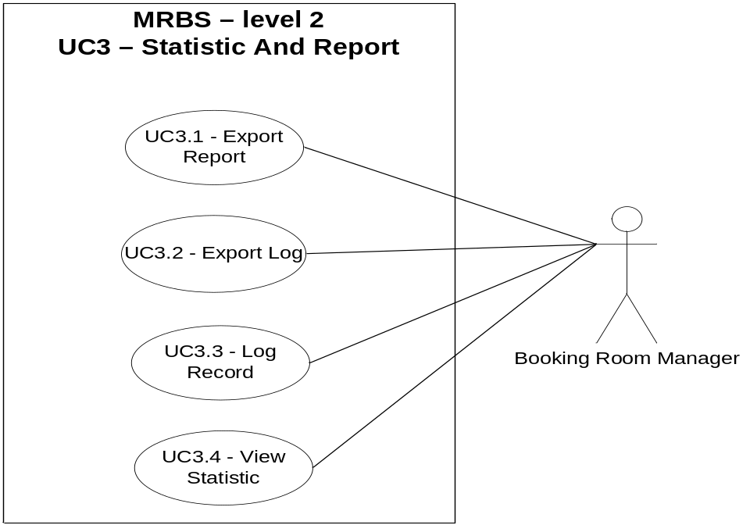
      - Room Management
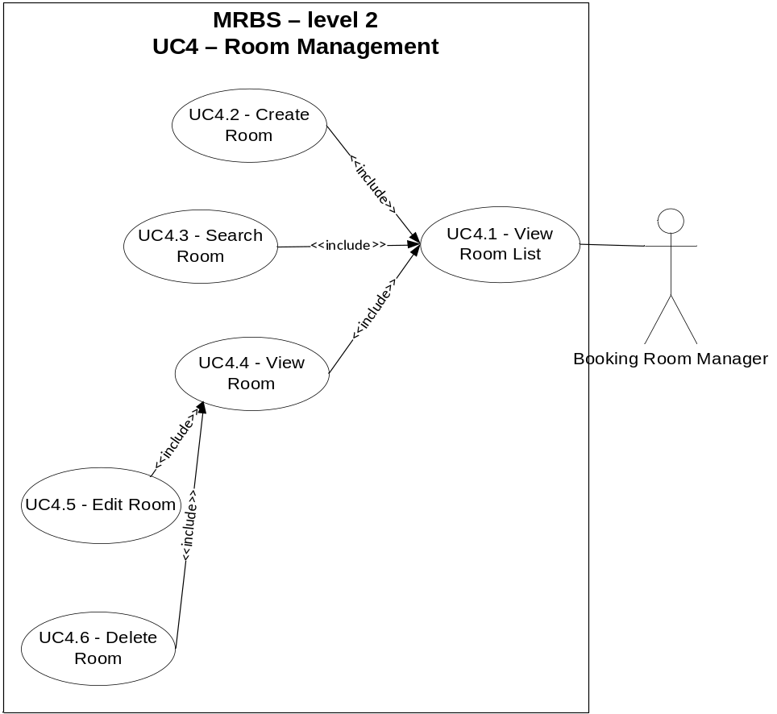
      - Group Borrower Management
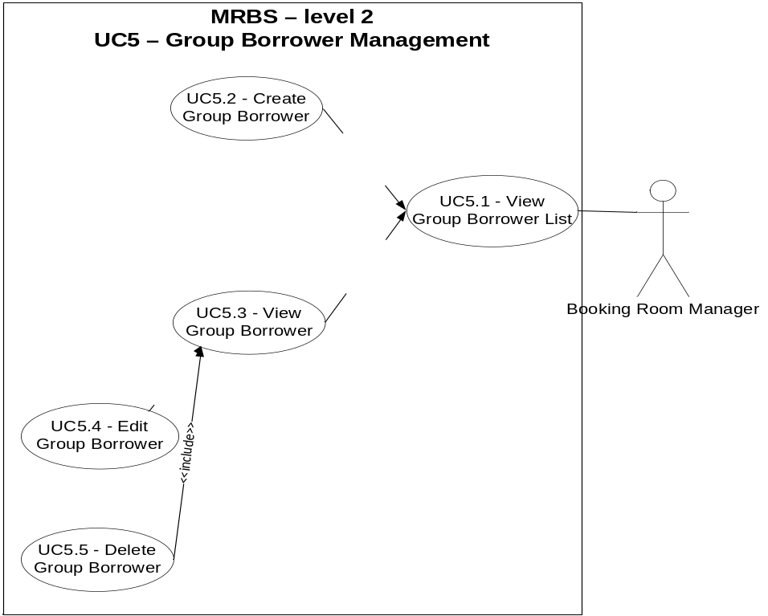
      - Borrower Management
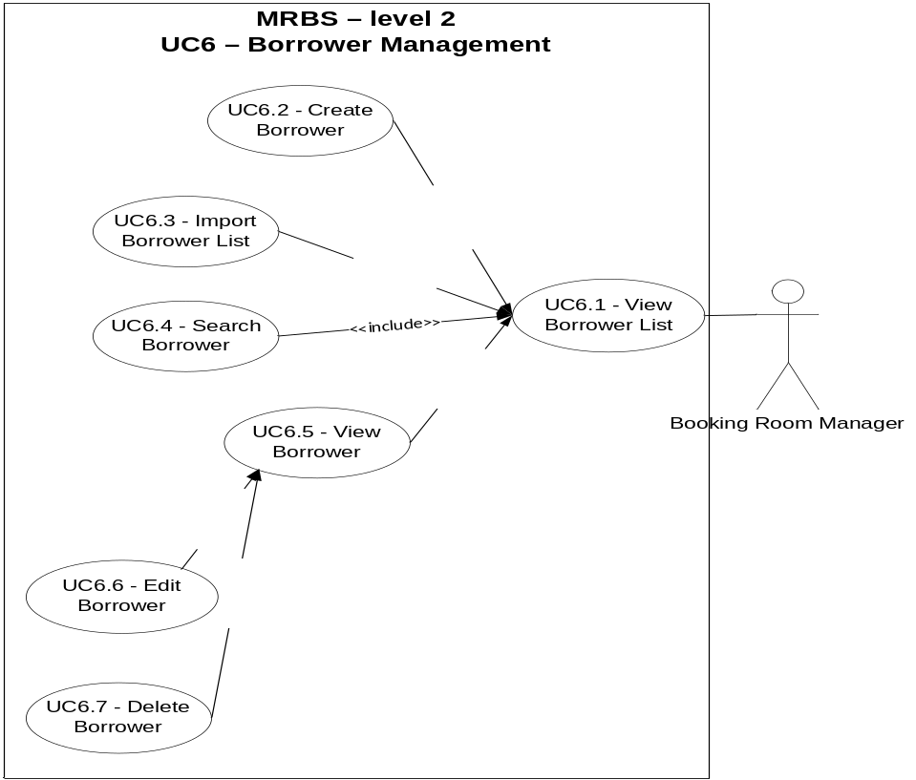
      - Email Management
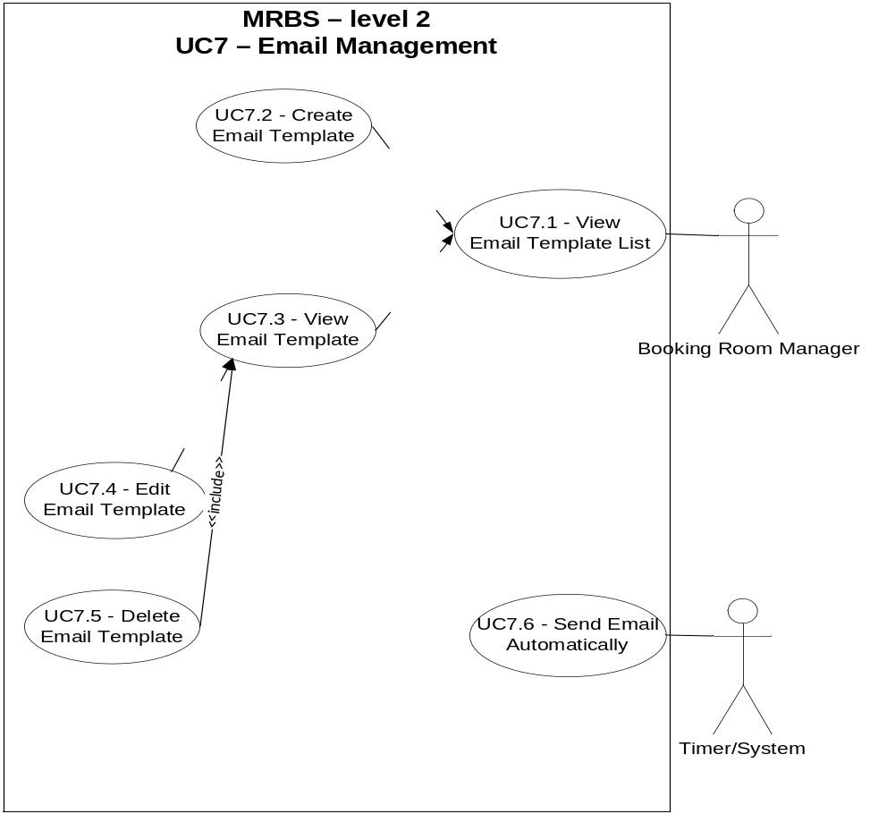
      - Recycle Bin Management
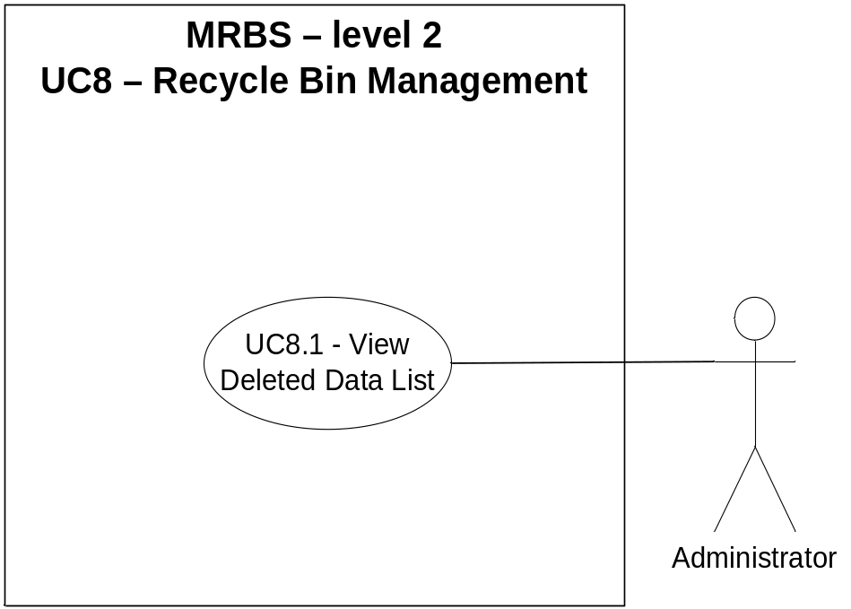
    - Use-case Table
Use Case ID | Use Cases Name | Primary Actor
UC1 | Account Management | Administrator
UC1.1 | View Account List
UC1.2 | Create Account
UC1.3 | Search Account
UC1.4 | View Account
UC1.5 | Edit Account
UC1.6 | Delete Account
UC1.7 | Reset Password
UC1.8 | Reset Admin’s Password
UC1.9 | Edit Current Account
UC1.10 | View Current Account
UC1.11 | Sign In
UC1.12 | Sign Out
UC2 | Booking Room Management | Booking Room Manager
UC2.1 | Booking Room
UC2.2 | View Booking Room List
UC2.3 | Search Booking Room
UC2.4 | View Booking Room
UC2.5 | Change Booking Room
UC2.6 | Cancel Booking Room
UC2.7 | Check In
UC2.8 | Check Out
UC2.9 | View Conflict List
UC2.10 | Resolve Conflict
UC2.11 | Resolve Conflict Automatically
UC3 | Statistic And Report | Booking Room Manager
UC3.1 | Export Report
UC3.2 | View Statistic
UC3.3 | Log Record
UC4 | Room Management | Booking Room Manager
UC4.1 | View Room List
UC4.2 | Create Room
UC4.3 | Search Room
UC4.4 | View Room
UC4.5 | Edit Room
UC4.6 | Delete Room
UC5. | Group Borrower Management | Booking Room Manager
UC5.1 | View Group Borrower List
UC5.2 | Create Group Borrower
UC5.3 | View Group Borrower
UC5.4 | Edit Group Borrower
UC5.5 | Delete Group Borrower
UC6. | Borrower Management | Booking Room Manager
UC6.1 | View Borrower List
UC6.2 | Create Borrower
UC6.3 | Import Borrower List
UC6.4 | Search Borrower
UC6.5 | View Borrower
UC6.6 | Edit Borrower
UC6.7 | Edit Violation
UC6.8 | Delete Borrower
UC6.9 | View Violation List
UC7 | Email Management | Booking Room Manager
UC7.1 | View Email Template List
UC7.2 | View Email Template
UC7.3 | Edit Email Template
UC7.4 | View Resend Email List
UC7.5 | Send Email Automatically
UC7.6 | Resend Email Automatically
UC8 | Recycle Bin Management | Administrator
UC8.1 | View Deleted Data List
Table 4. 2. 3. 1 - Use-case Description Level 1
    - Use-case Description
For more information, view file

Software Quality Attribute
ID | Quality Attribute Description
QA01 | Quality attribute: Performance  The program create report quickly, time is less than 5s.
QA02 | Quality attribute: Availability  System should provide availability with very small downtime periods.
QA03 | Quality attribute: Security  Password must be encrypted
QA04 | Quality attribute: Usability  The application easy to using the booking room function.

Performance Requirements

Usability Requirements

Other Requirements

Constraint Table
BC ID | Description | Difficulty  Ranking | Comments
BC.01 | Product is released on 08/18/2012 | 1 | Project team can hardly implement because no much experience
BC.02 | Project is developed by the team with 5 members. | 2 | Project team can hardly implement because

Business rule
ID | Description
BR.01 | Username do not over 50 characters and do not empty
BR.02 | Do not delete user which is sign in
BR.03 | Process sign in less than 15 seconds
BR.04 | Password only letters and numbers.
BR.05 | Password not over 24 characters and do not empty
BR.06 | New password do not same as Current Password
BR.07 | Confirm Current password duplicate new password
BR.08 | File input is file excel with format

Acceptance Criteria
The acceptance criteria for the product are defined by all Level 1 requirements. That is, Level 1 contains the minimum requirements that have to be met for the project to be accepted. Levels 2 and 3 represent likely and future inclusions respectively, the feasibility of which will be determined during the project.
Note that Level 1 requirements may not necessarily be implemented if they are replaced by corresponding Level 2 or 3 requirements.

Appendix 1
Name | File
Use Case Description

